COURSE

Cloud and Network Security- C3 – 2025

Week one assignment.

Student Details:

Name:

Godfrey Otieno Odhiambo

ID:
cs-cns10-25107

Submission Date:

September 23rd 2025.

Table of Contents
Chapter 1. Introduction 3
Class Activity 3
Packet Tracer 3
Installation 3
Part 1. Account Creation and logging in 3
Part 2. Account Navigation and Tracer File download 4
Part 3. File Installations Setup and Program Execution 5
3.1 Navigation to the download location. 5
3.2 Needed Operating system dependency check download and confirmation 5
3.3 Running Tracer Program for simulation. 6
Chapter 2. Simulation and Demonstrations 8
Part 1. Opening packet Tracer and loading the instruction file. 8
8
1.1 Generating the Web traffic and examine HTTP. 8
1.2 Displaying Elements of TCP/IP Protocol Suite. 11
Questions and Answers 11
Difference between the in layers and the out layers information columns. 14
Part 2 14
Conclusion Part 2 14

Chapter 1. Introduction
Networking is a wide field made up of different areas of knowledge. A good mastery of this area mainly combines Theory and practical mixed experience. This report details lessons and a reflection of theoretical mastered concept into hands-on understanding that enhances how networks works.
The combined foundational knowledge acquired and a focus on skills demonstrations showing packet tracer setup and configurations virtual networks setup and testing through simulations and performing analysis of network traffic movements within the network.

Class Activity

Packet Tracer
This a virtualization tool designed by the CISCO Systems, allowing users to create network topologies and imitate modern computer networks. It supports simulations on handling and configurations of different networking tools either through command lines or graphical interface forming a great lab used to practice, learn and teach IOT,Cybersecurity,Networking.

Installation
As mentioned earlier, packet tracer being a cisco system property, its installations,use and setup is per the CISCO requirements highlights on different being used operating systems. This is possible by navigating through there site https://www.netacad.com/ where this resource can be accessed and downloaded for local usage in a machine.

.

Part 1. Account Creation and logging in
Cisco Networking Academy being an IT skills-to -job program that provides technology educations and career opportunities,its through account creation here is where resources like packet Tracer can be found and many other related resources.
Here we will demonstrate account creation and show the successful account access interface.
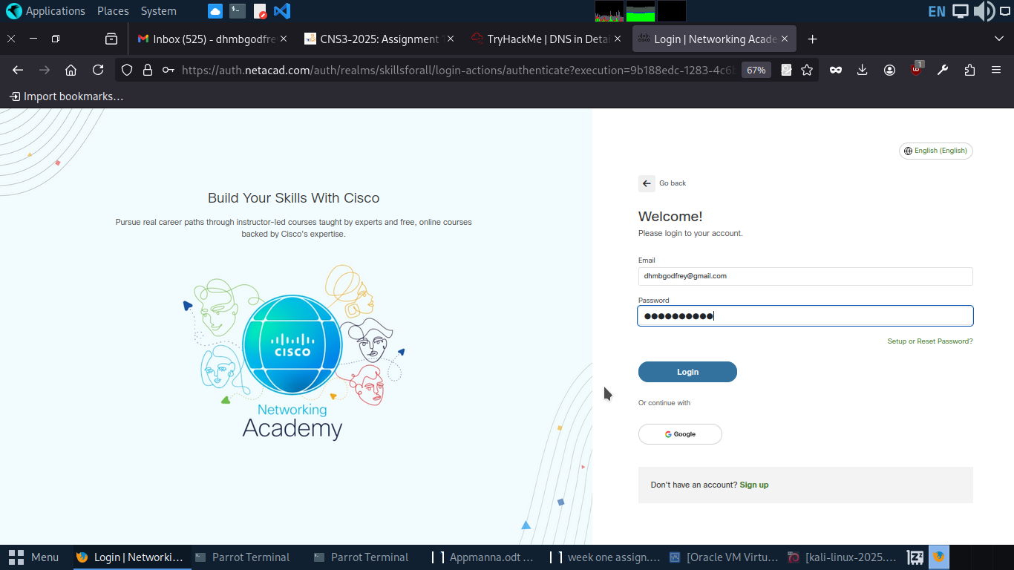
With Successful account access, then different needed resources as per the course of interest can be obtained.
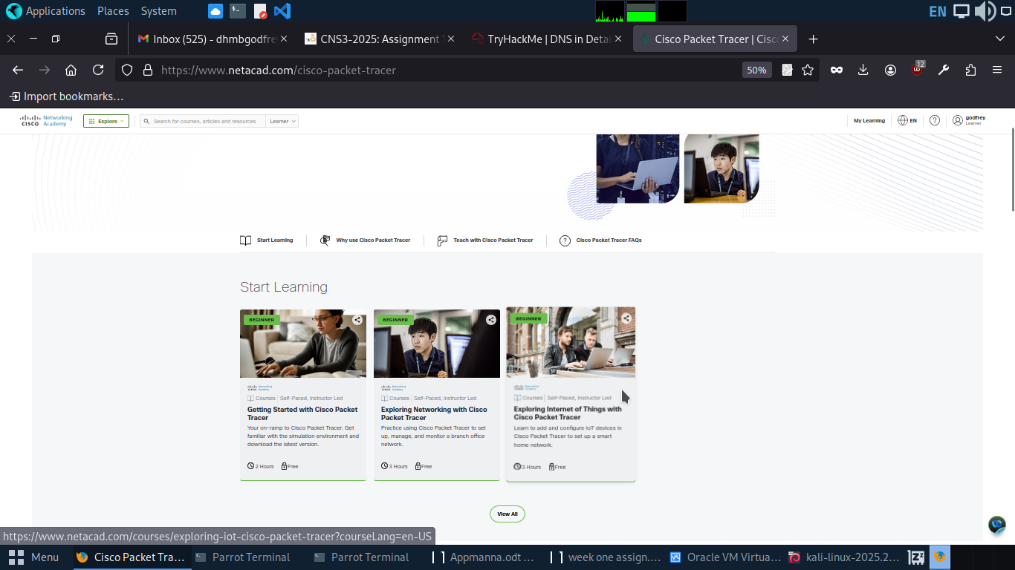

Part 2. Account Navigation and Tracer File download
Having interest in networking we will then navigate through the account options to where we can get the cisco packet Tracer for download. We will search the resources option and through it, we will be able to navigate to the resource hub where a download link based on the being used system packet Tracer download link is availed.
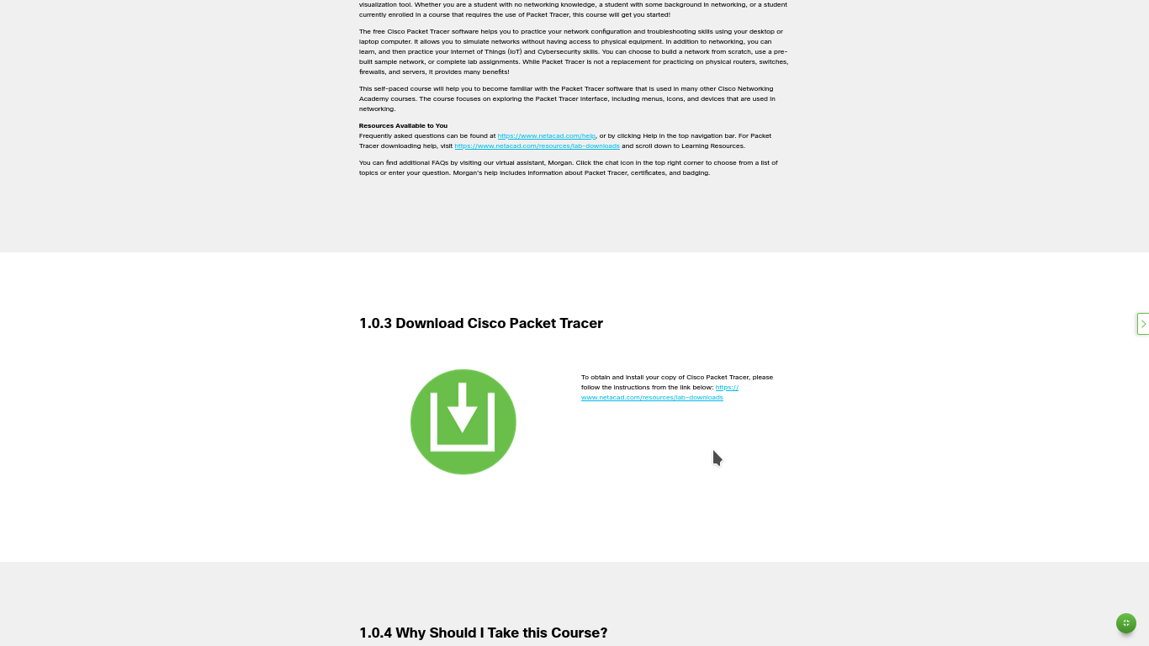
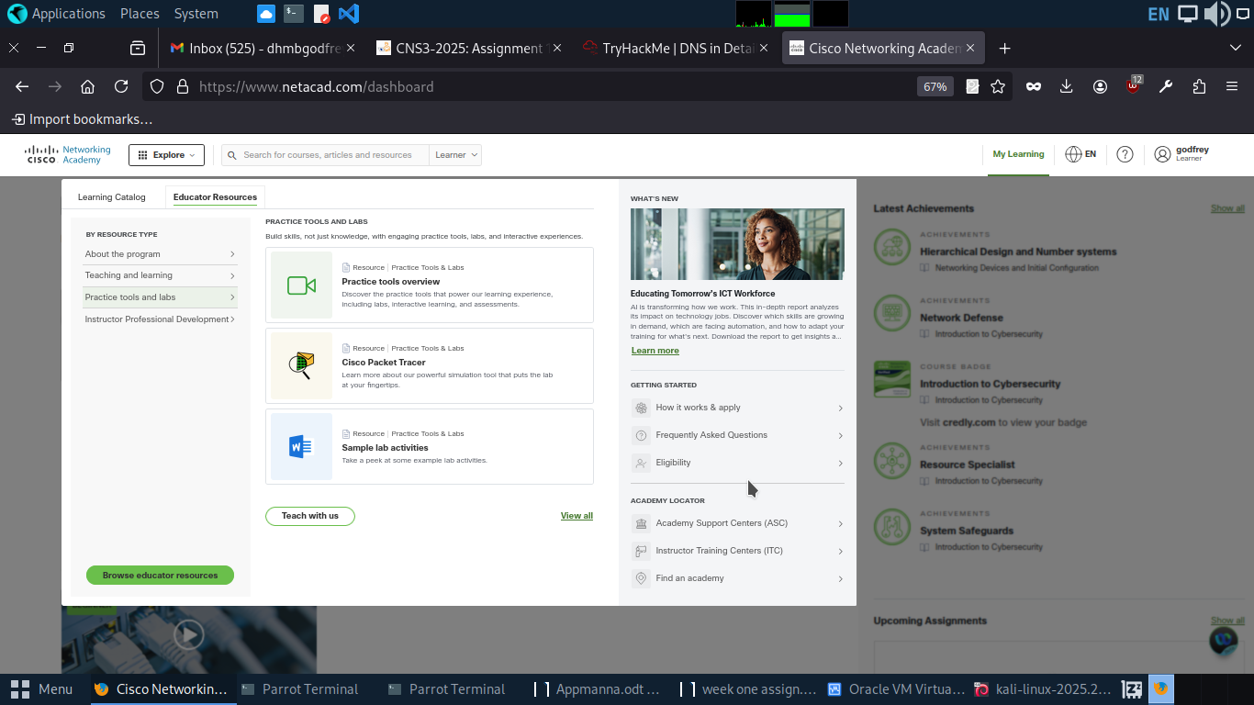

Part 3. File Installations Setup and Program Execution

3.1 Navigation to the download location.
Being a user of parrot operating system,selection of cisco package associated with the Ubuntu version is recommended. By clicking the link the the needed .deb file is downloaded and saved in downloads folder location.
With complete file download, through the use of command line we will navigate through the folders to the download location where the file is saved and stored.
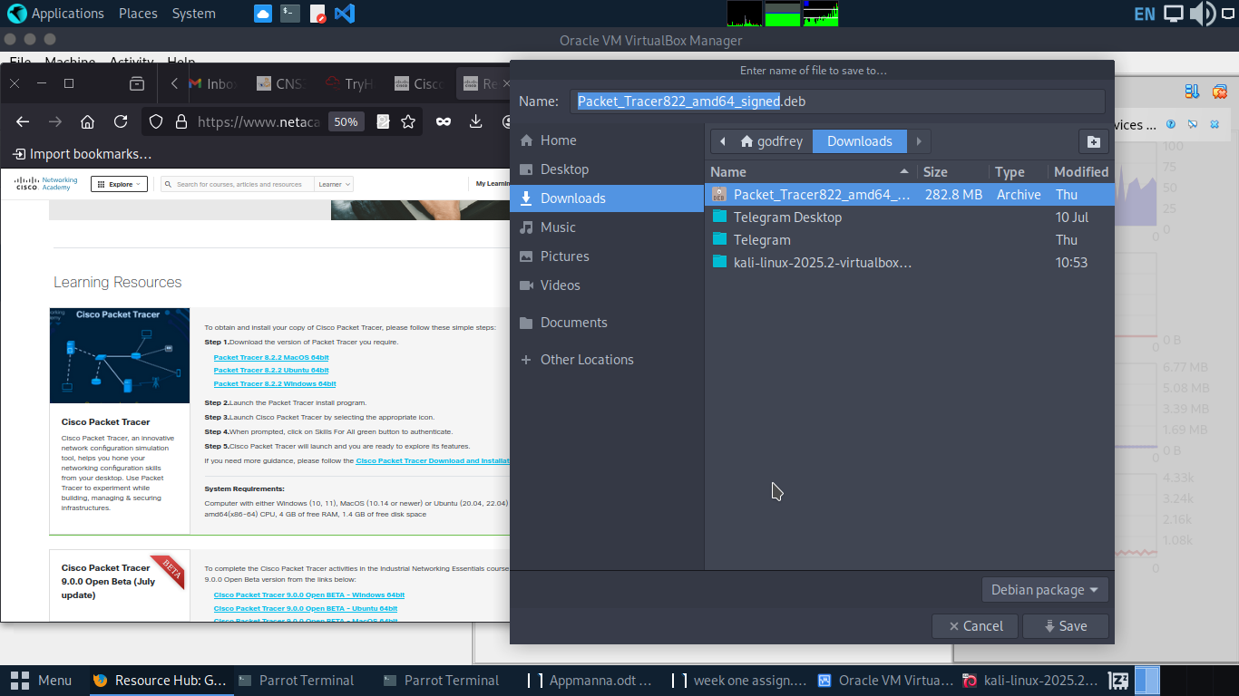

.

3.2 Needed Operating system dependency check download and confirmation
Being a relative new user of parrot these packages had to installed manually for the operations of the simulation networking tool.
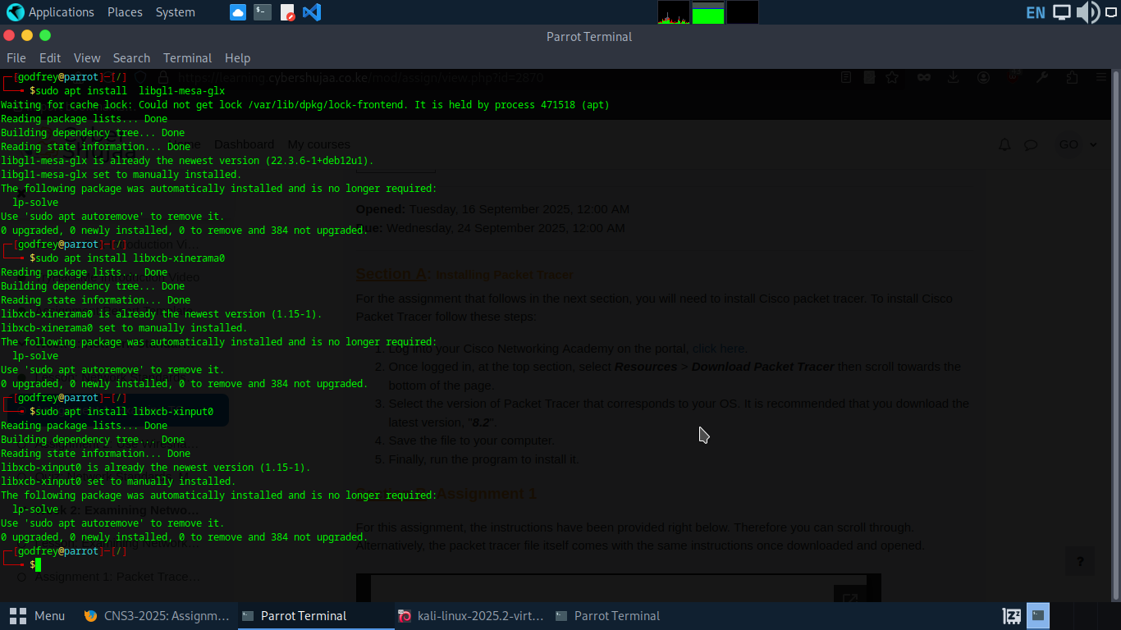
Packet tracer being a simulation software that have heavy dependency on graphical interface, the following dependencies are of essence to its operations.
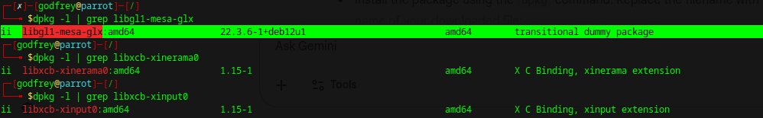
- The libgl1-mesa-glx is for Graphics library that supports the application hardware graphics card usage.
- Libxcb-xinerama0 for displaying of virtual screens as a single one entity most so across different monitors.
- libxcb-xinput0 for handling input devices being used to interact with the virtualization environment.

3.3 Running Tracer Program for simulation.
For backup reasons we will copy the downloaded file that we will use for installation. This is just a good practice just in case of modifications of the file that will make us remain with an affected copy.
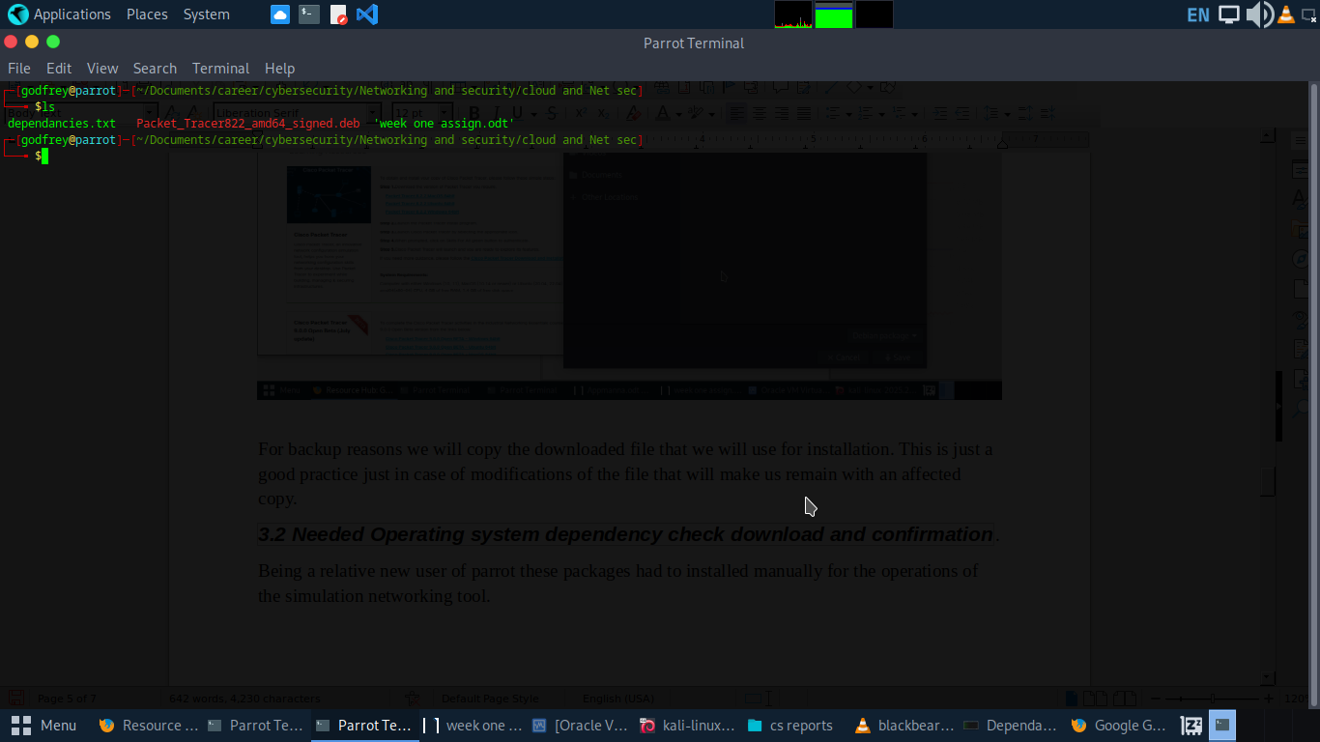
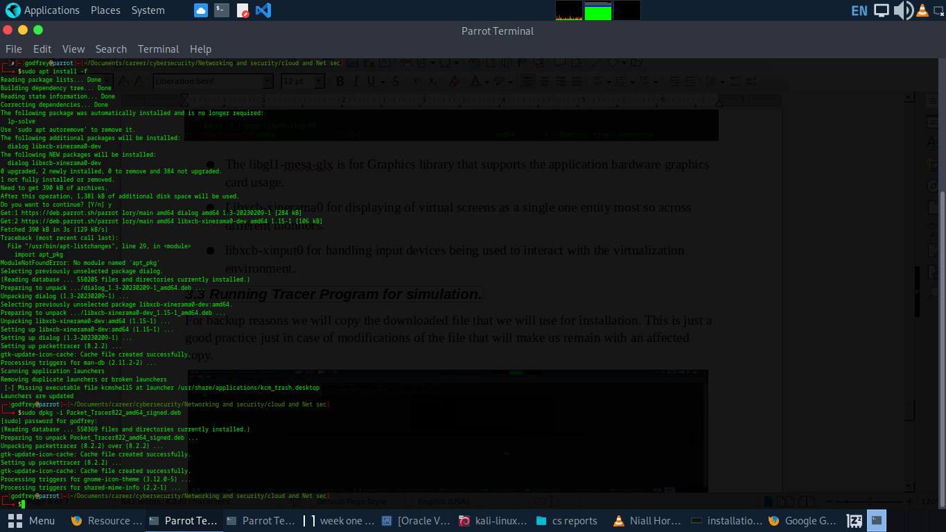

Chapter 2. Simulation and Demonstrations
Activity; Investigating TCP/IP and OSI models in Action

Objectives 1: Examine the HTTP web Traffic
Objectives 2: Display Elements of the TCP/IP Protocol Suite

Tools:
- laptop with an Installed Cisco Packet Tracer
- Instruction file guide with virtual set-up web server and web client.

Part 1. Opening packet Tracer and loading the instruction file.

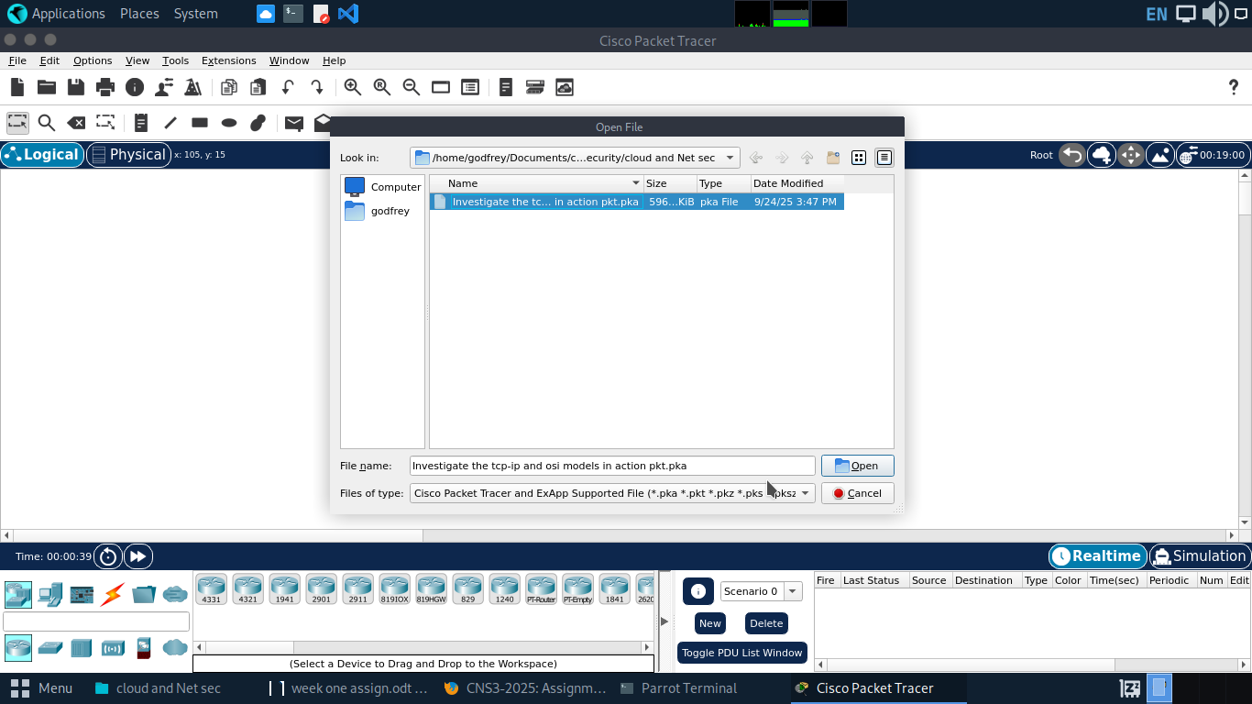
To the already downloaded P. Tracer, we will load the instruction file and follow up each and every detailed instruction.

1.1 Generating the Web traffic and examine HTTP.
Switching from normal state of packet tracer(Realtime) to simulation mode.
The known default state used when packet tracer starts is the real-time mode. In this activity Simulation mode is encouraged since is gives full control of all the networking events by the user and at the same time it allows for the smart simulation where by the packets are being represented as envelopes and viewing the detailed information of events easy.
Event setup and selection.
In this activity, the point of interest is on the generation of the HTTP traffics. P. Tracer supports different Events through its filter management options. The communication being illustrated through the simulation (client -server) web request communication is mainly through the HTTP.

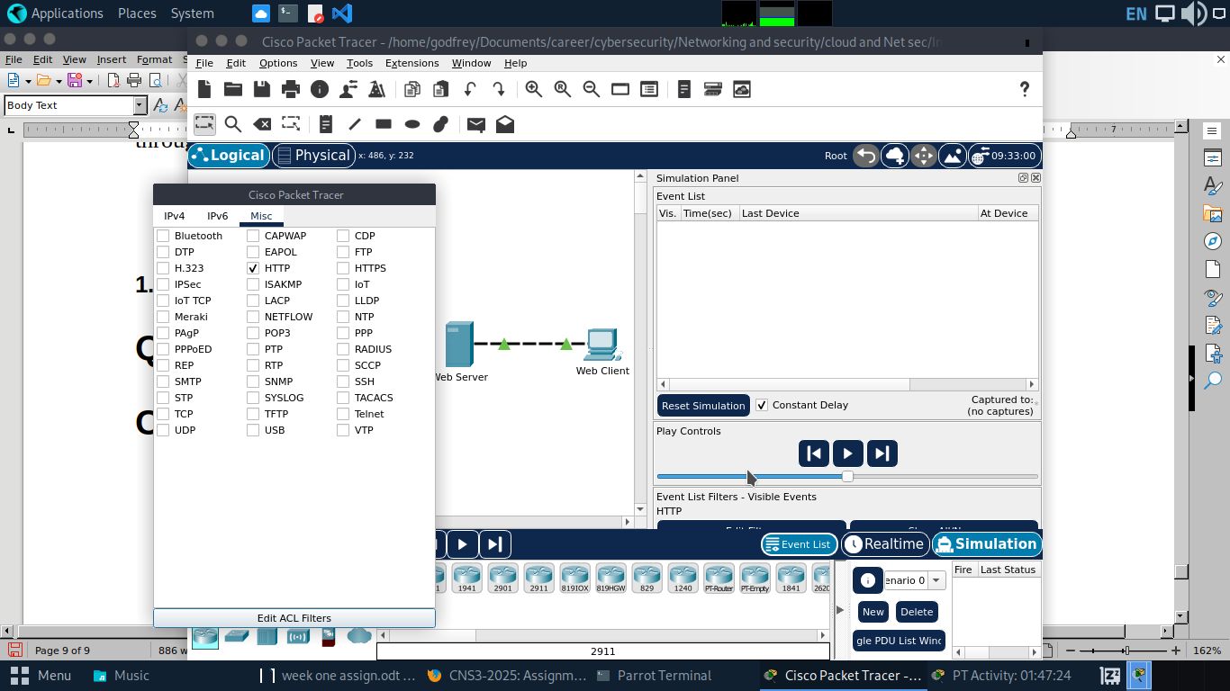
Generating the HTTP web traffics.
An action of web client requesting a web page through its web browser by typing http://www.osi.local on the search bar with go action click leads to generation of event list through forward simulation button.

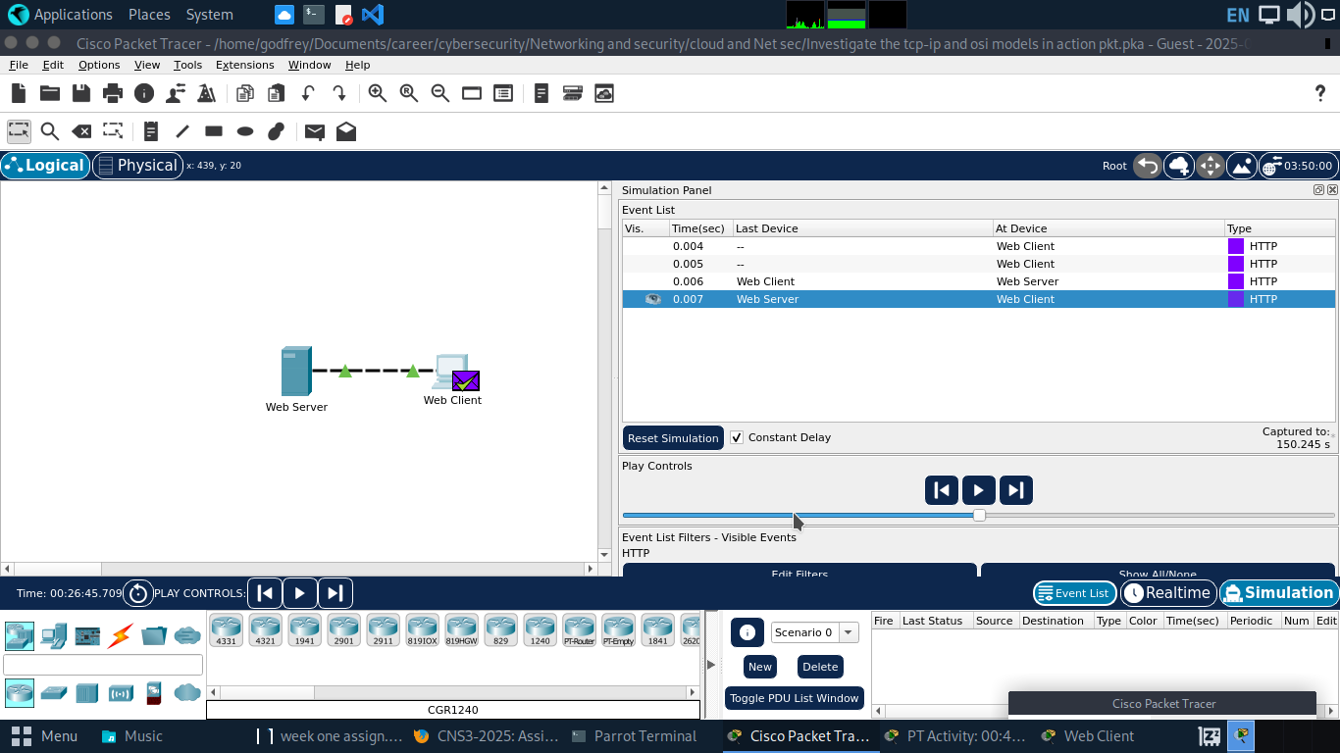
Examination of PDU information at Device.
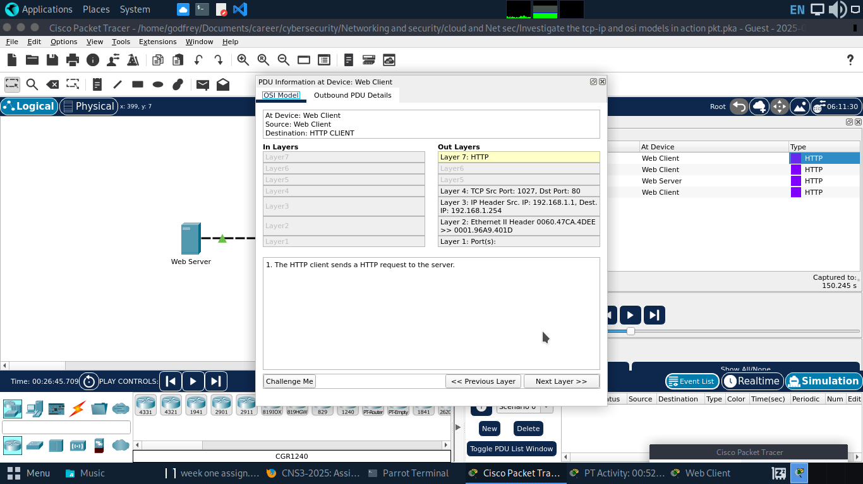

1.2 Displaying Elements of TCP/IP Protocol Suite.

Questions and Answers
OSI MODEL

The change explanation of the web browser.
As a result of server response in connection to the client request through the browser,the displayed message shows the Http response confirming the requested resource feedback.
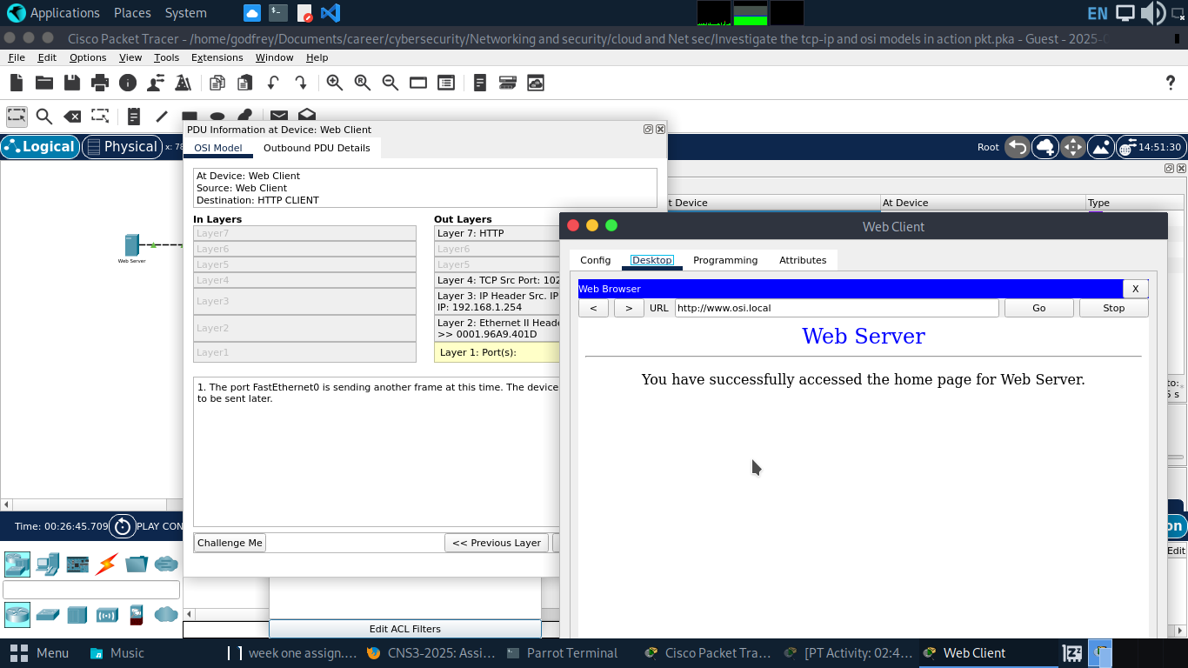
Information listed in the numbered steps directly below the In Layers and Out Layers boxes for Layer 7 is the HTTP client sends a HTPP request to serever.
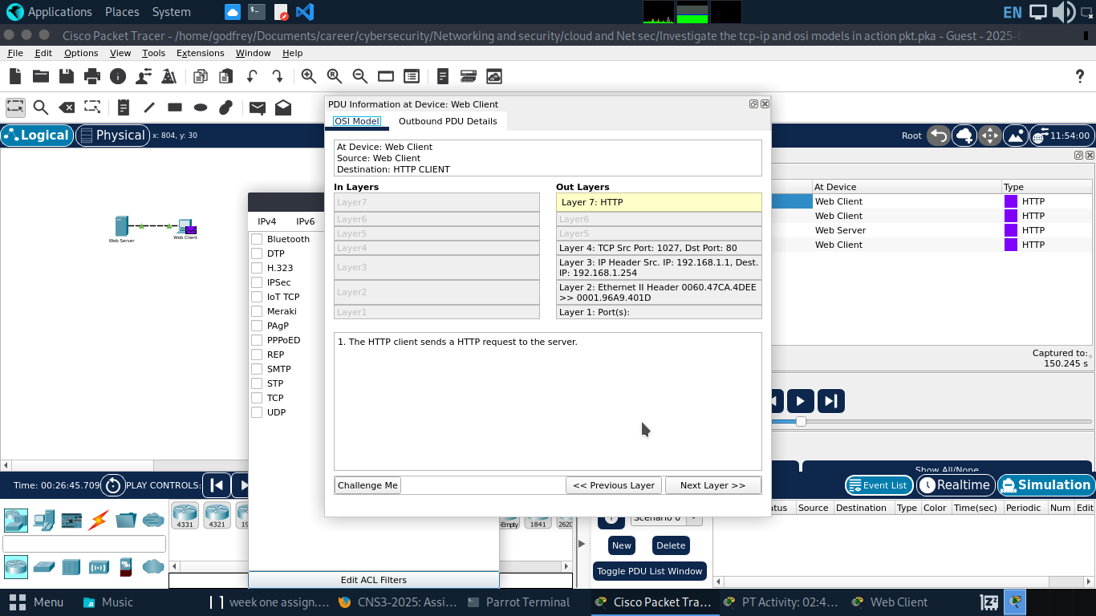
The Dst Port value for Layer 4 under the Out Layers column is 80.
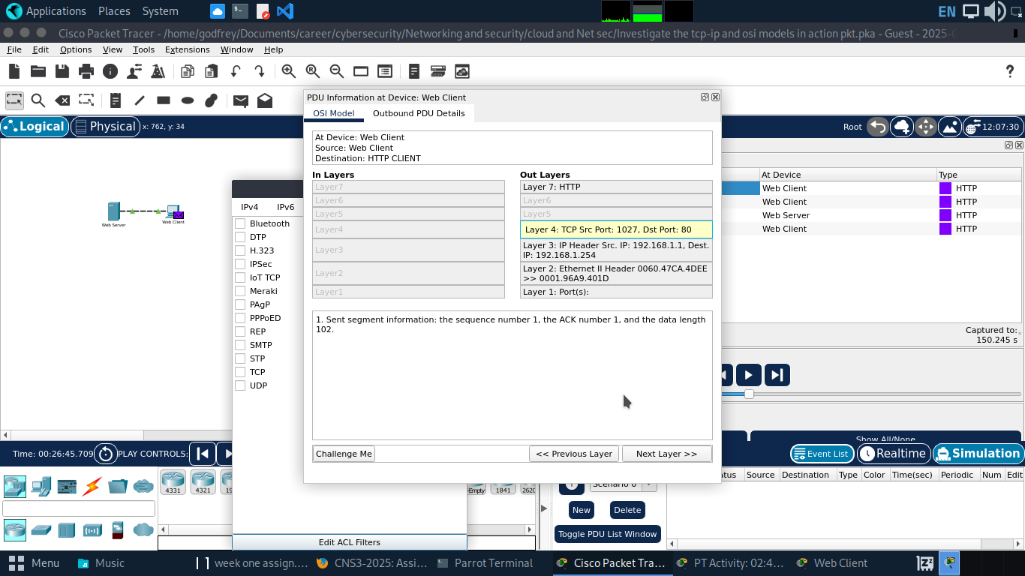
The Dest. IP value for Layer 3 under the Out Layers column is 192.168.1.254
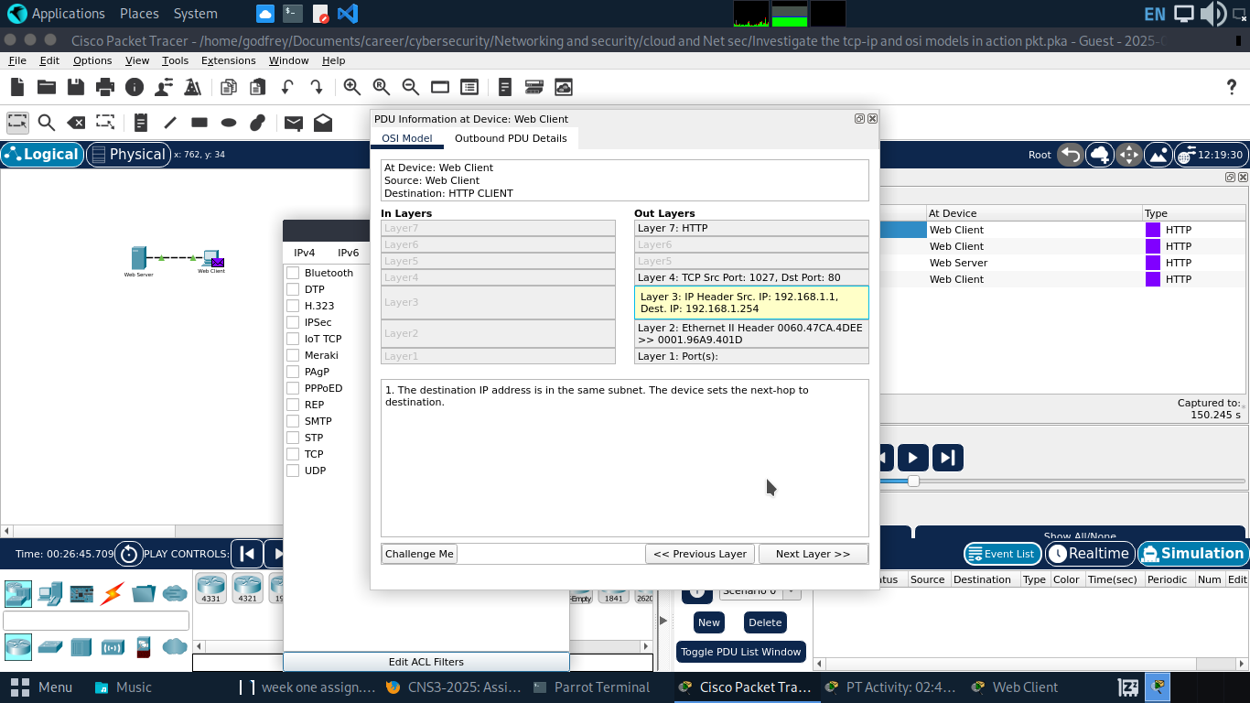

What information is displayed at Layer 2 under the Out Layers column packets header information.

OUTBOUND PDU
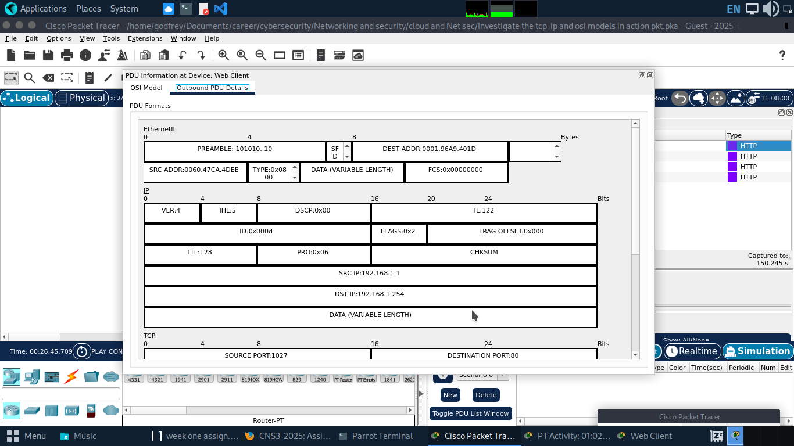
The common information listed under the IP section of PDU Details as compared to the information listed under the OSI Model tab is the source address and the destination address 192.168.1.1 and 192.168.1.254 respectively associated with layer 3 of the OSI model.
The common information listed under the TCP section of PDU Details, as compared to the information listed under the OSI Model tab,are port for destination and source of 80 and 1027 respectively in connection to layer 4 on the OSI side.
The Host listed under the HTTP section of the PDU Details is www.osi.local associated with layer 7 under OSI Model.

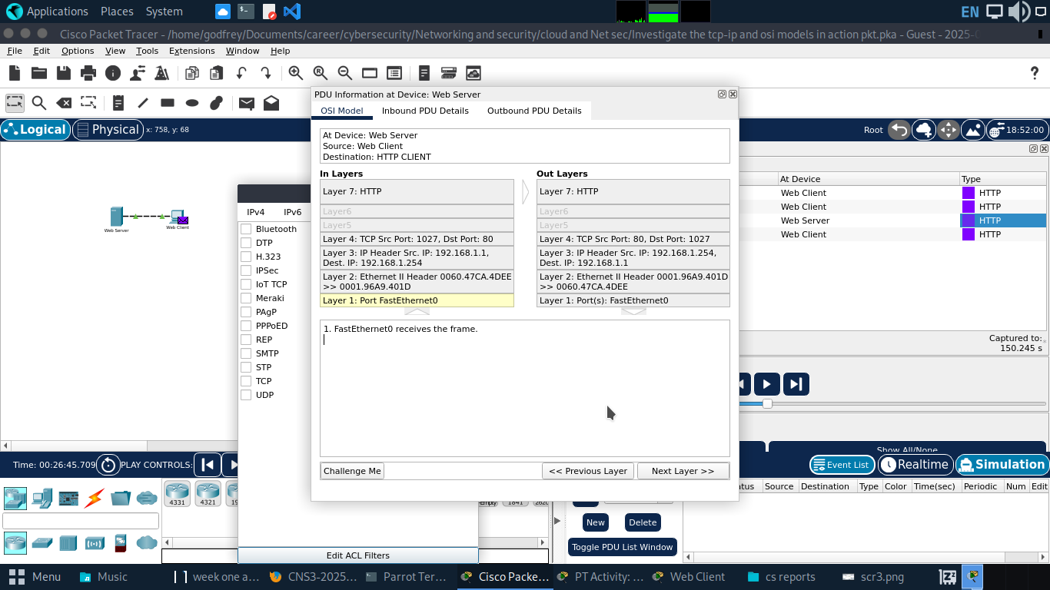

Difference between the in layers and the out layers information columns.
With in layers the device is receiving the clients requests, with layer 1 Receiving the frame,With the sources (ip and ports)of the in layer acting as the destinations for the out layer and

Part 2. display Elements of the TCP/IP Protocol Suite

Step 1: View Additional Events
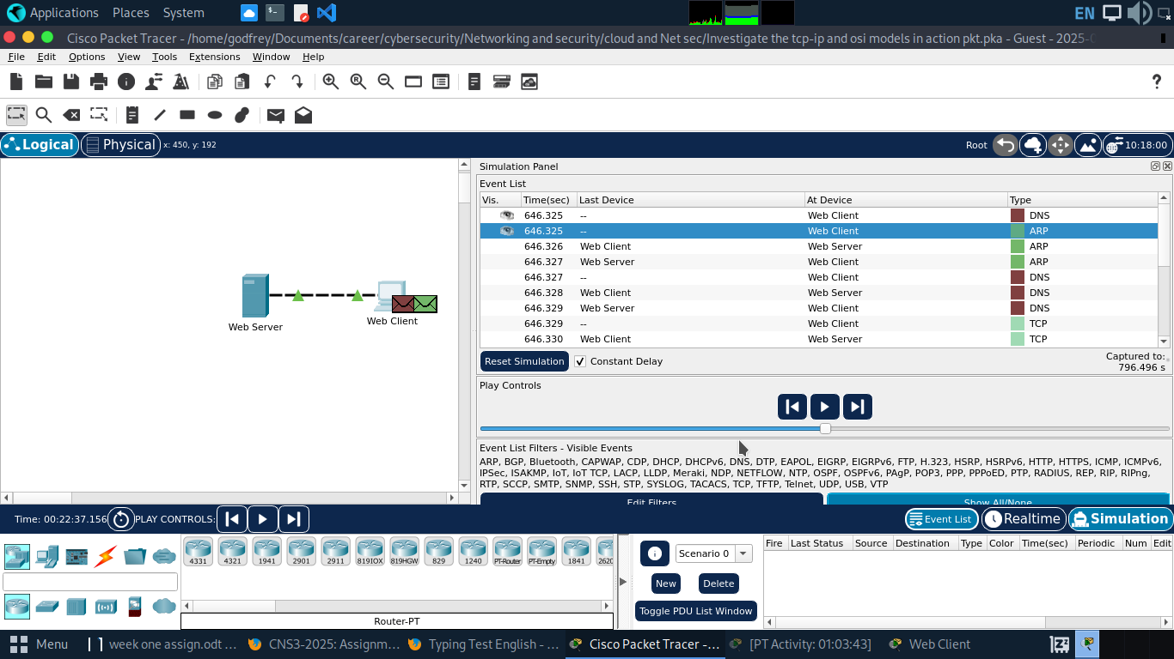
Additinal events viewed when Show All/None Is clicked include DNS event type,ARP event type and TCP event type.
Information is listed in the NAME field: in the DNS QUERY section is www.iso.local
The device in which the PDU was captured is the web client.
Value listed next to ADDRESS: in the DNS ANSWER section of the Inbound PDU Details is 4
Find the first HTTP event in the list and click the colored square box of the TCP event immediately following this event. Highlight Layer 4 in the OSI Model tab
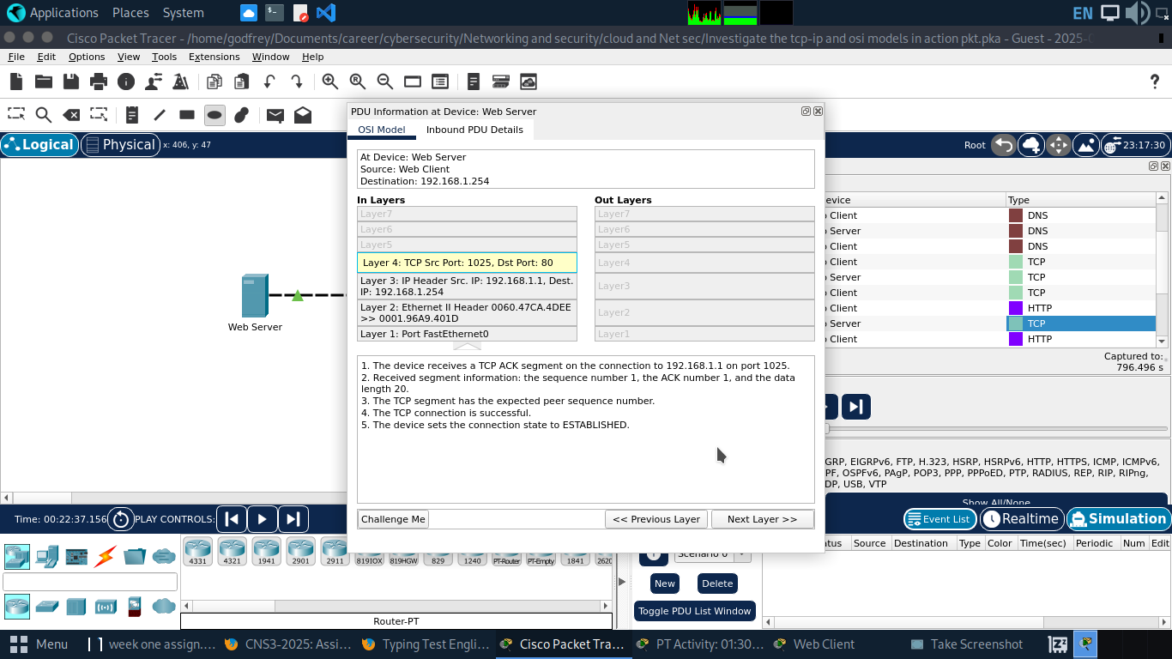
In the numbered list directly below the In Layers and Out Layers, what is the information displayed under items 4 and 5
The purpose of last TCP event, based on the information provided in the last item in the list (should be item 4)
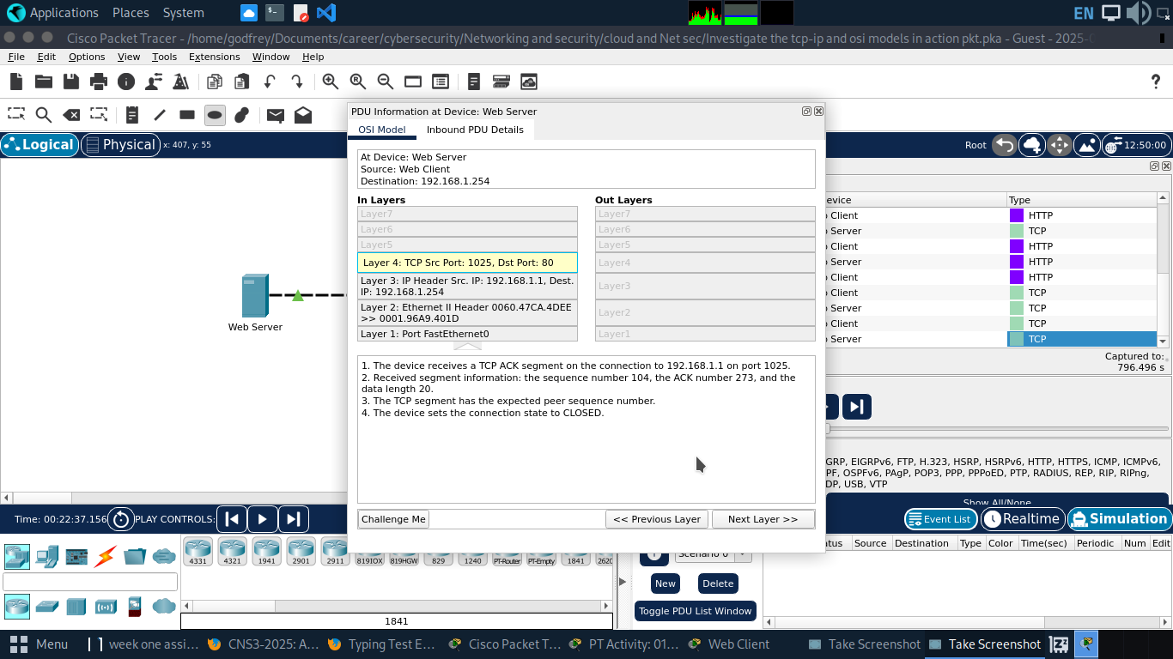
This event terminates the the connection establishments previously being used between the server and the web client

Conclusion
This

